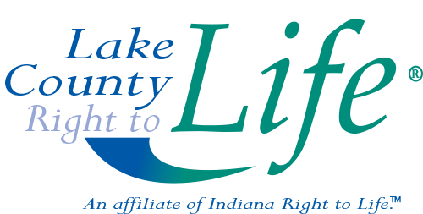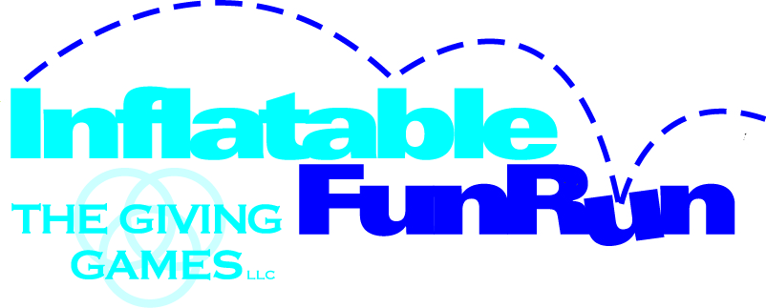
Run/Walk Participant Name: __________________________________________
An Inflatable Fun Run Benefitting Lake County Right to Life
*Checks must be made payable to THE GIVING GAMES and turned in by 9/13/17*
Name | Address | City | Zip | Email | Phone # | Paid Cash | Paid Check | Donation Amount
Donate Online at: www.TheGivingGamesNOW.org Questions? 844-FUN-RUN1 (844-386-7861)

