Lake county right to life  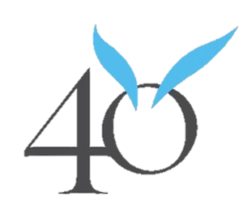  Days for life  What  The campaign is a 40-day time frame in which people in local communities pledge to pray and fast for an end to abortion. They also commit to a 40-day prayer vigil outside an abortion center or Planned Parenthood facility.  When  March 1st – April 9th  Where  Merrillville Planned Parenthood  8645 Connecticut St, Merrillville, IN 46410 | 12,668 lives saved since 2007  mission  - Prayer and fasting  - Constant vigil  - Community outreach  focus  40 Days for Life focuses on the spiritual aspects of the battle to end abortion.  Persons of all faiths are invited and welcome to participate in 40 Days for Life activities.  Contact  For volunteer sign ups  please contact:  Rachel E. Klein  (219) 798-9950  Elizabethhon19@gmail.com  Lake County Right to Life  (219) 838-1138  office@lakecortl.org

